  - Sarana dan Prasarana
3.3.1 Ruang kuliah, ruang kerja dosen, kantor dan perpustakaan
Tabel 3.9. Ruang Kuliah, Ruang Dosen, Kantor dan Perpustakaan
No. | Jenis Ruang | Jumlah Unit (buah) |  | Jumlah Luas (m2) | Kapasitas total (orang) | Kepemilikan
 |  |  |  |  |  | SD | SW
1. | Ruang Kuliah | 8 | Ruang 1  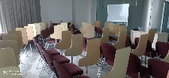  Ruang 2  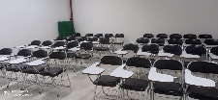  Ruang 3  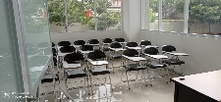  Ruang 4  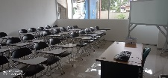  Ruang 6  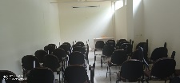  Ruang 7  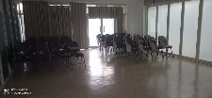  Ruang 8  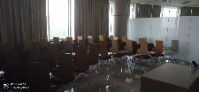 | 288 | 240 | √ | -
2. | Ruang Dosen | 2 | Ruang 1  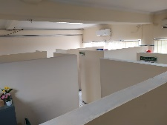  Ruang 2  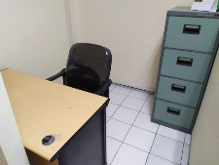 | 36 | 18 | √ | -
3. | Kantor | 3 | Ruang Direktur  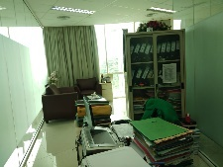  Ruang Guru Besar  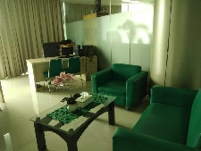  Ruang Prodi  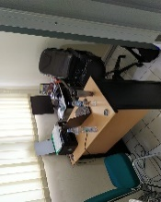 | 36 | 24 | √ | -
4. | Perpustakaan | 1 | 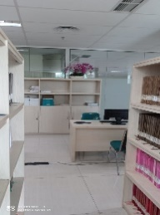 | 24 | 6 | √ | -
TOTAL |  | 14 |  | 384 | 257

Keterangan: SD = Milik Sendiri; SW = Sewa/Kontrak/Kerjasama. Luasan minimal untuk setiap ruangan sesuai dengan peraturan perundang- undangan.

    - Ruang belajar mandiri
Tabel 3.10. Ruang Belajar Mandiri
No. | Jumlah ruang yang tersedia untuk belajar mandiri | Total luas (m2) | Kapasitas Total | Kepemilikan |  | Kelengkapan Perabot | Akses Internet*
 |  |  |  | SD | SW
1 | Ruang SCL (Student Centered Learning)  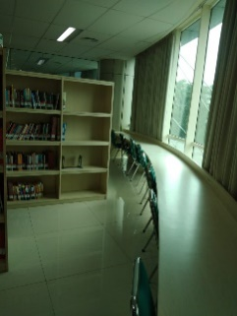 | 36 | 18 | √ | - | Meja, Kursi, PC, Printer | Wi-Fi Access & LAN
2 | Ruang Community Center  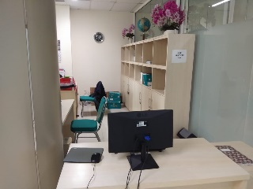 | 36 | 18 | √ | - | Meja, Kursi, PC, Printer | Wi-Fi Access
3 | Ruang Cyber Library  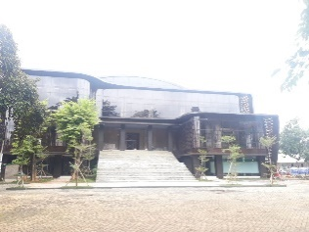 | 272 | 120 | √ | - | Meja, Kursi, PC, Printer | Wi-Fi Access
Total |  | 344 | 156

3.3.3 Ruang akademik khusus
Tabel 3.11. Ruang Akademik Khusus
No. | Nama Ruang Akademik | Jumlah Luas | Jumlah Unit | Kapasitas total (orang) | Kepemilikan
 |  |  |  |  | SD | SW
1 | Ruang Bimbingan Thesis  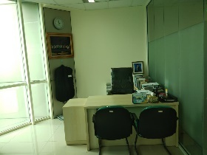 | 64 | 4 | 40 | √ | -
2 | Ruang Seminar  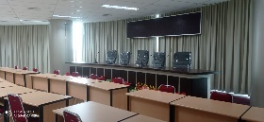 | 182 | 1 | 128 | √ | -
3 | Data Communications & Networks  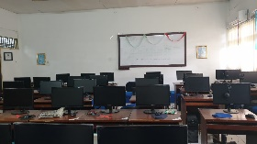 | 96 | 1 | 50 | √ | -
4 | E-Commerce  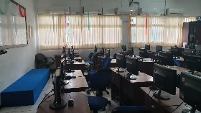 | 54 | 1 | 30 | √ | -
5 | Artificial Intelegence  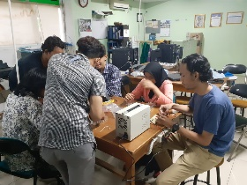 | 55 | 1 | 30 | √ | -
6 | Computer Vision & Multimedia  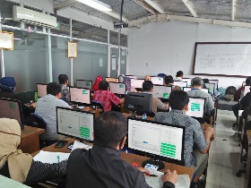 | 64 | 1 | 40 | √ | -
7 | Blended Learning  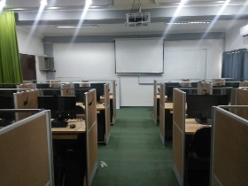 | 54 | 1 | 30 | √ | -

3.3.4 Peralatan praktikum/praktik/bengkel kerja/lahan praktik/PKL atau yang tujuan penggunaanya sejenis

Tabel 3.12 Peralatan Praktikum
No. | Nama Laboratorium | Jenis Peralatan & tahun produksi | Jumlah Unit | Kepemilikan
 |  |  |  | SD | SW
1 | Data Communications & Networks | TP-Link TL-SG1024D, 24-Port Digabit Switch  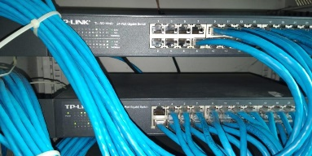  Spesifikasi :  1. 24 10/100/1000Mbps ports  2. Innovative energy-efficient technology saves power consumption  3. Supports MAC address self-learning, Auto MDI/MDIX and Auto negotiation  4. Plug & play design | 3 | √
 |  | D-Link DGS-1024C  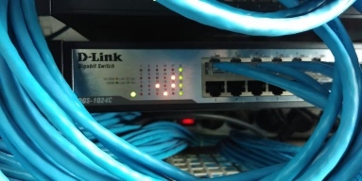  Spesifikasi :  1. 24x 10/100/1000 Mbps ports  2. Ethernet : 10Mbps (half duplex), 20Mbps (full duplex)  3. Fast Ethernet : 100Mbps (half duplex), 200Mbps (full duplex)  4. Gigabit Ethernet : 2000Mbps (full duplex)  5. Auto MDI/MDIX adjustment for all ports  6. Power : 100 to 240 V AC | 1 | √
 |  | Netgear DGN 1000  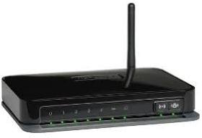  Kecepatan : 150 Mbps | 1 | √
 |  | Gamemax CPU (Asrock Motherboard,msi Radeon, intel Core i5, Tp Link Adaptor (Tahun 2018). | 50 | √
 |  | Viewsonic Touchscreen LCD  Monitor (Tahun 2018). | 50 | √
 |  | Logitech MK200 Keyboard +  Mouse (Tahun 2018). | 50 | √
 |  | Server  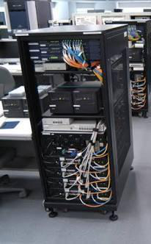  Processor : Intel Core i7-1087H  RAM : 8GB DDR4 ECC  Hard Disk : 1 TB atau Terabyte  Grafis : Aspeed AST1400 with 64MB VRAM  Sistem Operasi : Windows® Server 2008 | 1 | √
2 | E-Commerce | TP-Link TL-SF1024D    Spesifikasi :  1. Standards and Protocols IEEE 802.3i, IEEE 802.3u, IEEE 802.3x  2. Interface 24 10/100Mbps RJ45 Ports (Auto Negotiation/Auto MDI/MDIX)  3. Network Media 10BASE-T: UTP category 3, 4, 5 cable (maximum 100m)  4. 100BASE-TX: UTP category 5, 5e or above cable (maximum 100m)  5. Fan Quantity Fanless  6. Power Supply External Power Adapter(Output: 9VDC/0.6A)  7. Power Consumption Maximum: 3.19W (220V/50Hz) | 1 | √
 |  | D-Link DES-1024R    Spesifikasi :  1. Sub Type : Fast Ethernet  2. Ports : 24 x 10/100  3. Cabling Type : Ethernet 100Base-TX, Ethernet 10Base-T  4. Communication Mode : Full-Duplex, Half-Duplex | 1 | √
 |  | D-Link DGS-1024C    Spesifikasi :  1. 24x 10/100/1000 Mbps ports  2. Ethernet : 10Mbps (half duplex), 20Mbps (full duplex)  3. Fast Ethernet : 100Mbps (half duplex), 200Mbps (full duplex)  4. Gigabit Ethernet : 2000Mbps (full duplex)  5. Auto MDI/MDIX adjustment for all ports  6. Power : 100 to 240 V AC | 1 | √
 |  | D-Link DES-1024R    Spesifikasi :  1. Sub Type : Fast Ethernet  2. Ports : 24 x 10/100  3. Cabling Type : Ethernet 100Base-TX, Ethernet 10Base-T  4. Communication Mode : Full-Duplex, Half-Duplex | 1 | √
 |  | Netgear DGN 1000  Kecepatan : 150 Mbps | 1 | √
 |  | Gamemax CPU (Asrock Motherboard,msi Radeon, intel Core i5, Tp Link Adaptor (Tahun 2018). | 30 | √
 |  | Viewsonic Touchscreen LCD  Monitor (Tahun 2018). | 30 | √
 |  | Logitech MK200 Keyboard +  Mouse (Tahun 2018). | 30 | √
 |  | Server  Processor : Intel Core i7-1087H  RAM : 8GB DDR4 ECC  Hard Disk : 1 TB atau Terabyte  Grafis : Aspeed AST1400 with 64MB VRAM  Sistem Operasi : Windows® Server 2008 | 1 | √
3 | Artificial Intelegence | ROUTER ASUS RT-N10U  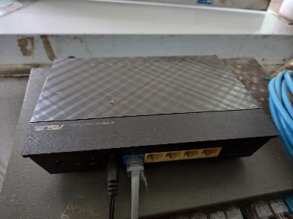  Type : Wireles  Wi-fi Speed : 150 Mbps  Wi-Fi Band : Single  Frequency : 2.4 Ghz  Technology : 902.11 b/ g/ n  LED Indicator : yes  Port : RJ-45 (LAN), USB  Data Encryption : Yes  Firewall Type : DoS, SPI  Dimensions : 173 x 130 x 35 mm | 1 | √
 |  | SWITCH D-LINK DES-1016D  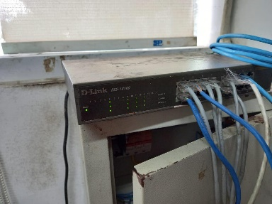  Interface : Auto MDI / MDIX adjustment for all ports  Number of Ethernet Port : 16  Speed : 100 Mbps  Power Consumtion : 4.48 W  Features  : Auto MDI / MDIX crossover for all ports , Secure  store-and-forward switching scheme , Full / half-duplex for Ethernet / Fast Ethernet  speeds , Supports 9 216 byte jumbo frames , Back pressure at half-duplex operation ,  Wire-speed reception and transmission , Store and-Forward switching method , Autonegotiation for each port, QoS (8 queues, strict mode)  Dimension : 280 x 180 x 44 mm | 1 | √
 |  | Server  Processor : Intel Core i7-1087H  RAM : 8GB DDR4 ECC  Hard Disk : 1 TB atau Terabyte  Grafis : Aspeed AST1400 with 64MB VRAM  Sistem Operasi : Windows® Server 2008 | 1 | √
 |  | Netgear DGN 1000  Kecepatan : 150 Mbps | 1 | √
 |  | Gamemax CPU (Asrock Motherboard,msi Radeon, intel Core i5, Tp Link Adaptor (Tahun 2018). | 30 | √
 |  | Viewsonic Touchscreen LCD  Monitor (Tahun 2018). | 30 | √
 |  | Logitech MK200 Keyboard +  Mouse (Tahun 2018). | 30 | √
4 | Multimedia | TP-Link TL-SF1024D  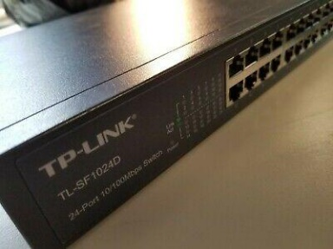  Spesifikasi :  • Standards and Protocols IEEE 802.3i, IEEE 802.3u, IEEE 802.3x  • Interface 24 10/100Mbps RJ45 Ports (Auto Negotiation/Auto MDI/MDIX)  • Network Media 10BASE-T: UTP category 3, 4, 5 cable (maximum 100m)  • 100BASE-TX: UTP category 5, 5e or above cable (maximum 100m)  • Fan Quantity Fanless  • Power Supply External Power Adapter(Output: 9VDC/0.6A)  • Power Consumption Maximum: 3.19W (220V/50Hz) | 1 | √
 |  | D-Link DES-1024R  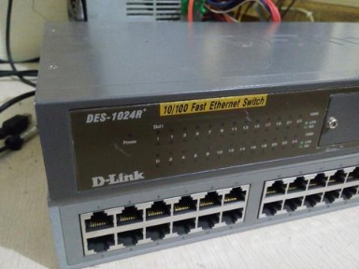  Spesifikasi :  • Sub Type : Fast Ethernet  • Ports : 24 x 10/100  • Cabling Type : Ethernet 100Base-TX, Ethernet 10Base-T  • Communication Mode : Full-Duplex, Half-Duplex | 1 | √
 |  | D-Link DGS-1024C  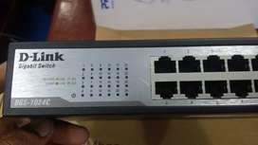  Spesifikasi :  • 24x 10/100/1000 Mbps ports  • Ethernet : 10Mbps (half duplex), 20Mbps (full duplex)  • Fast Ethernet : 100Mbps (half duplex), 200Mbps (full duplex)  • Gigabit Ethernet : 2000Mbps (full duplex)  • Auto MDI/MDIX adjustment for all ports  • Power : 100 to 240 V AC | 1 | √
 |  | Server  Processor : Intel Core i7-1087H  RAM : 8GB DDR4 ECC  Hard Disk : 1 TB atau Terabyte  Grafis : Aspeed AST1400 with 64MB VRAM  Sistem Operasi : Windows® Server 2008 | 1 | √
 |  | Netgear DGN 1000  Kecepatan : 150 Mbps | 1 | √
 |  | Gamemax CPU (Asrock Motherboard,msi Radeon, intel Core i5, Tp Link Adaptor (Tahun 2018). | 30 | √
 |  | Viewsonic Touchscreen LCD  Monitor (Tahun 2018). | 30 | √
 |  | Logitech MK200 Keyboard +  Mouse (Tahun 2018). | 30 | √
5 | Blended Learning | Server  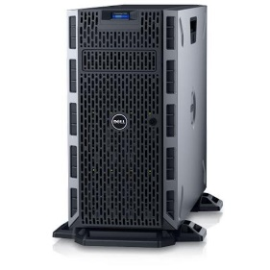  Sfesifikasi  - Intel Xeon E-3-1225 v6 3.3GHz, 8M cache, 4C/4T, turbo (73W  - Chassis with up to 8, 3.5"" Hot Plug Hard Drives  - 8GB UDIMM, 2400MT/s, Single Rank, x8 Data Width / iDRAC8, Express  - 2TB 7.2K RPM NLSAS 512n 3.5in Hot-plug Hard Drive  - On-Board LOM 1GBE Dual Port (BCM5720 GbE LOM) | 1 | √ | -
 |  | Gamemax CPU (Asrock Motherboard,msi Radeon, intel Core i5, Tp Link Adaptor (Tahun 2020). | 30 | √
 |  | Viewsonic Touchscreen LCD  Monitor (Tahun 2020). | 30 | √
 |  | Logitech MK200 Keyboard +  Mouse (Tahun 2020). | 30 | √
 |  | Logitech Mobile Wireless  Speaker (Tahun 2020). | 30 | √
 |  | Logitech Webcam (Tahun 2020). | 30 | √
 |  | Logitech Stereo Headset (Tahun 2020). | 30 | √
 |  | TP link AC1750 Wireless  Access Point (Tahun 2020). | 30 | √
 |  | Kabel HDMI Converter | 30 | √
 |  | Kabel converter VGA  to DVI-D (Tahun 2020). | 30 | √

